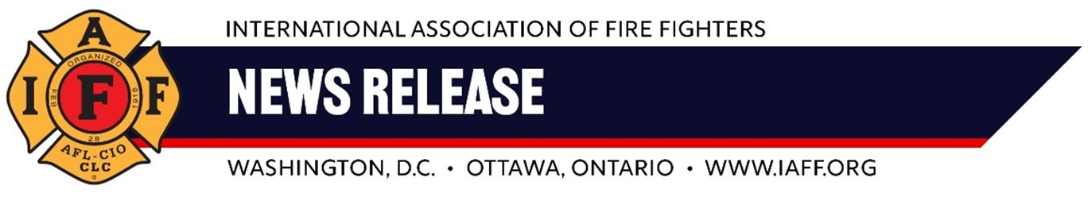  
 **For immediate release                                                                 Contact:** Jamie Van Iterson   
**Monday, July 7, 2024**509 306-0159;[**iaff2**95@gmail.com](mailto:iaff295@gmail.com)

**U.S. Army Reduces Firefighting Capacity at Yakima Training Center**

*The decision to cut wildfire response to a single helicopter*    
*threatens safety in surrounding communities.*

*YAKIMA, Washington* -- The U.S. Army’s recent decision to dramatically reduce fire protection resources at the Yakima Training Center has put thecommunities of Kittitas, Yakima, and Grant Counties at greater risk of spreading wildfires.

Earlier this year, the U.S. Army reduced its aerial firefighting requirement to a single UH 60 Blackhawk helicopter, dramatically reducing the amount of water aircrews can deliver to wildfires at the Training Center just east of Yakima. In addition, the U.S. Army has begun rotating in aircrews who are untrained in wildfire response weekly.

These policy changes, an abrupt shift from more than 30 years of official U.S. Army fire protection policy, occur as the 2024 wildfire season begins. The change has already led to water delivery incidents that could have injured fire fighters and damaged equipment.

Statewide fire resources have already been deployed around Yakima to battle wildfires, including the Slide Ranch Fire, which has destroyed over a dozen structures. Meanwhile, the Federal Emergency Management Agency (FEMA) has authorized more federal funds to help protect against the building wildfire season.

“The Yakima Training Center Fire Department fire fighters are committed to protecting this essential Army facility and all residents and businesses in surrounding communities. The U.S. Army’s decision to slash resources now as wildfires threaten Yakima makes no sense and should be immediately reversed,” said Jamie Van Iterson, president of the Federal Firefighters of Yakima Local F-295.”

###