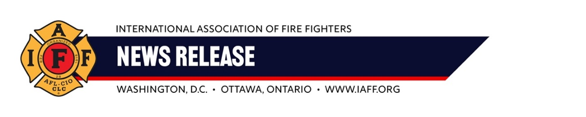
For Immediate Release Contact: Tim Burn
Wednesday, June 26, 2024 202 230-7167; tburn@iaff.org

IAFF Applauds New Federal Rule Protecting
Fire Fighters from Hazardous Materials
WASHINGTON, DC — The International Association of Fire Fighters (IAFF) is proud to support a new federal rule ensuring first responders get access to information about hazardous chemicals on trains immediately following a derailment.
"Ensuring fire fighters rapid access to hazardous chemical information is essential to an effective emergency response," said IAFF General President Edward A. Kelly. "Fire fighters are all-hazard responders, often first to arrive at incidents like train derailments. Getting fire fighters and rescue workers the information they need in an emergency helps us mitigate further risk, protect the community, and stay safe on the job."
The rule, finalized on June 24, 2024, requires train operators to immediately inform first responders about any hazardous materials they are transporting. This helps fire fighters make informed decisions about the tools and protective gear necessary to address an accident.
The rule also calls for expanding the AskRail app, which provides quick access to train cargo information, and mandates that even the smallest railroads have a plan to rapidly deliver crucial details to local fire departments. Additionally, the rule requires annual testing of these plans to ensure their effectiveness.
The February 2023 Norfolk Southern derailment and subsequent chemical exposure in East Palestine, Ohio emphasized the need for the new rule. During that incident, fire fighters experienced significant delays in obtaining information about the chemicals involved, jeopardizing the lives of civilians in surrounding communities and the first responders on scene.
"The IAFF is committed to pushing for the reforms needed to protect the public and our members from hazardous materials emergencies," said Kelly.
###

