**For immediate release                                              Contact:** Nick Lascu  
**Tuesday, September 10, 2024**                                   216 233-7856; [nlascu15@gmail.com](mailto:nlascu15@gmail.com)

**Cleveland Secures 2028 International Association of Fire Fighters Convention**

*This biennial meeting of North America’s fire fighters union is expected to boost economic activity and showcase all that ‘Forest City’ has to offer.*

*CLEVELAND, Ohio* – The City of Cleveland will host the 59th Biennial Convention of the International Association of Fire Fighters (IAFF) in 2028.   
  
Leaders from the City of Cleveland, the Association of Cleveland Fire Fighters IAFF Local 93, and Destination Cleveland joined forces in Boston, MA, last month to secure a bid for the biennial meeting of North America’s largest fire fighters union.   
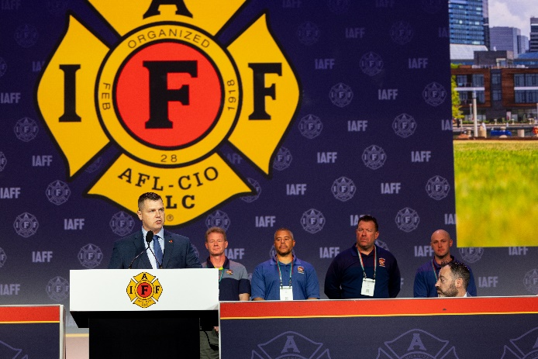

This years-long effort paid off when nearly 4,000 fire fighters from across the U.S. and Canada [voted unanimously](https://youtu.be/oB6cwVquAcg) to choose Cleveland as the host city, where IAFF affiliate leaders will conduct business on behalf of its more than 350,000 members.

Cleveland Mayor Justin M. Bibb and Local 93 President Jake Konys presented this bid, supported by Destination Cleveland, the region’s destination marketing and management organization.

 “Our city has a rich tradition of honoring and supporting fire fighters, and we are proud to be selected as the host for this distinguished event,” stated Mayor Justin Bibb. “This achievement is a testament to the commitment, hard work and dedication of our local fire fighters, represented by Local 93 President Jake Konys, and the collaboration with IAFF General President Edward Kelly and Destination Cleveland. We look forward to welcoming fire fighters from across the country and highlighting the important work they do to keep our communities safe. We are excited to showcase everything our city has to offer.”

“We are stronger, and our City is better, because of the hard work and service of our IAFF members. It is an honor to have been selected, and we look forward to welcoming our Brothers and Sisters to our hometown in 2028,” said President Konys.

He continued, “Our City is rising, and we have much to showcase. Cleveland is home to a strong labor force, and we will continue collaborating with our City’s Leadership to build a better tomorrow. I look forward to working with Mayor Bibb, and City Hall, and the incredible talent we have at Destination Cleveland to make this convention an economic driver for the region.”

 With the support of General President Kelly and General Secretary-Treasurer Frank Líma, the 2028 Convention is sure to be a success and an excellent opportunity to display all that Cleveland and the IAFF have to offer.   
  
“We look forward to working with Local 93 and its impressive partners in Cleveland to make 2028 truly memorable,” said General President Kelly.

“Cleveland wins when we collaborate to bring events, meetings, and conventions to our city,” said David Gilbert, president and CEO of Destination Cleveland. “The IAFF’s selection of Cleveland reflects the commitment of many organizations and individuals to advancing our city’s reputation as both an event host as well as an overall destination city. With an estimated economic impact of nearly $1.8 million and the likelihood of delivering 10,500 room nights, this event is another significant opportunity to show visitors what makes our city so special.”

The IAFF Convention is no small task. In Boston last month, the IAFF hosted several notable speakers, including Massachusetts Gov. Maura Healy, former U.S. Secretary of Labor Marty Walsh, and both vice presidential candidates, to name a few.

**ABOUT THE IAFF**

*The International Association of Fire Fighters is the driving force behind nearly every advance in fire and emergency services in the 21st century. With headquarters in Washington, D.C., and Ottawa, Ontario, the IAFF represents more than 350,000 professional fire fighters and EMS professionals. Its members protect more than 85 percent of the population throughout the U.S. and Canada.*

*###*