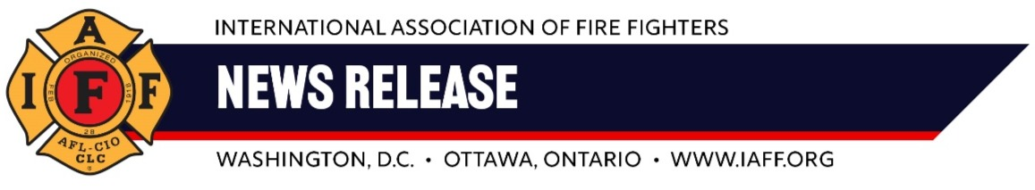
For Immediate Release Contacts:
Saturday, May 4, 2024 Tim Burn: (202) 230-7167; tburn@iaff.org
Matt Lowry: (206) 715-6839; mlowery@iaff.org

Boeing Locking Out On-Site Firefighters Despite Federal Investigations into Safety Practices

RENTON, WASH. – Boeing has locked out the firefighters who protect its employees, property, and aircraft. The company took this drastic step in its efforts to force the firefighters to accept an unfair contract proposal.
International Association of Fire Fighters Local I-66 members comprise the 125 firefighters and emergency medical workers responding to incidents at Boeing’s Washington facilities. Despite their critical work, I-66 members earn up to 30 percent less than firefighters at nearby fire departments.
Boeing’s lockout is intended to punish, intimidate, and coerce its firefighters into accepting a contract that undervalues their work.
“Putting corporate greed over safety, Boeing has decided to lockout our members and the safety of the Washington facilities has been needlessly put at risk. When it’s fight or flight, firefighters don’t give up; we fight. And when we do, we fight for the benefits and protections that make everyone safer,” said Edward Kelly, IAFF General President. “We won’t be intimidated by the bosses at Boeing. We’ll stand up and fight.”
In addition to sub-standard wages, Boeing’s “best and final” contract offer would require its firefighters to work 19 years before reaching top pay. Some other Boeing employees currently “top out” after five years.
The company’s ongoing treatment of Local I-66 members has led some to seek employment at local fire departments, driving years of training and experience out of Boeing.
“When is Boeing going to make safety a priority? When is Boeing finally going to listen?” said Casey Yeager, president of Local I-66.
“In underpaying its firefighters, Boeing says we shouldn’t compare ourselves to local municipal departments. The truth is, the fires and incidents we respond to are often more dangerous and, if not contained quickly, can result in millions of dollars in damage to airplanes Boeing sells around the world,” said Yeager.
Boeing has saved billions in insurance costs by employing its own on-site firefighters. In addition to being on the ground during all aircraft operations, Boeing firefighters respond to medical emergencies at the facility and train employees on fire safety practices.
The lockout will negatively impact surrounding cities and counties, whose fire and EMS agencies will now respond to emergency calls at Boeing’s Washington facilities. The tactic will siphon resources from neighboring communities and increase stress on local first responders.
“Boeing Firefighters want to work. We also want to be treated with dignity and a fair contract,” Yeager said. “The aerospace industry in America is at a turning point. Our members are committed to improving the safety culture of the Boeing Company. But we refuse to let a multi-billion-dollar company resolve its years of mismanagement on the backs of firefighters. It’s time for Boeing to come back to the table and do right by its customers, employees, and community.”
ABOUT THE IAFF
The International Association of Fire Fighters (IAFF) is the driving force behind every advance in the fire and emergency services in the 21st century. With headquarters in Washington, D.C., and Ottawa, Ontario, the IAFF represents nearly 350,000 professional fire fighters, emergency medical workers, and rescue workers. Our members protect more than 85 percent of the population throughout the United States and Canada.
###

